Go to chrome

Type selenium ide

Add to chrome(if opt not there then zoom out screen and click opt)

Click on chrome extentions and select selenium IDE

Create new proj

Top left new test

Top right corner rec

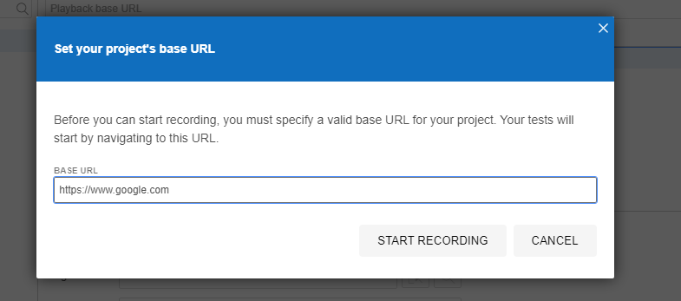

Start recording

Create new test give name

Command to open website : open

Do things

AUTOMATION TESTING :

Use online webdriver to upload things and all pdf and all

https://www.techlistic.com/p/selenium-practice-form.html

Eg. 